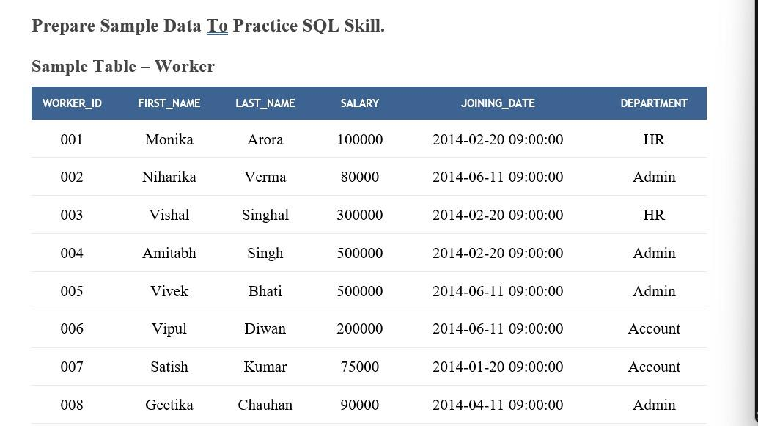

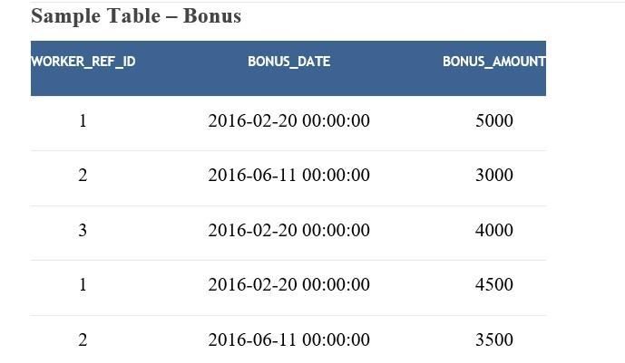

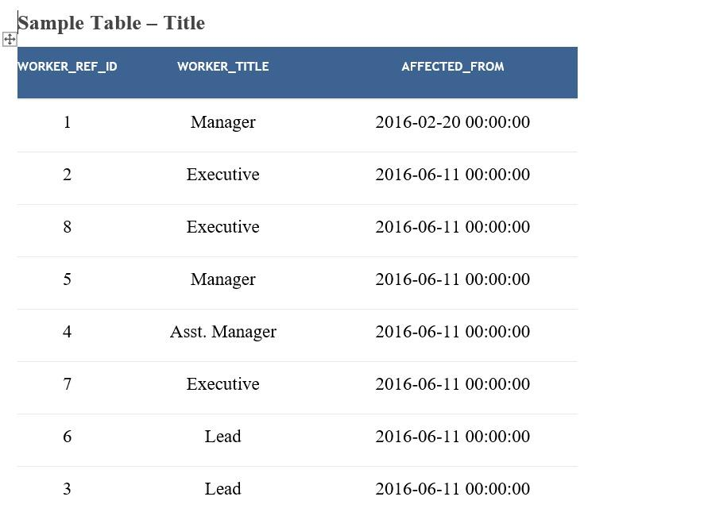

Code To insert the data and all

CREATE DATABASE ORG123;

SHOW DATABASES;

USE ORG123;

CREATE TABLE Worker (

WORKER_ID INT NOT NULL PRIMARY KEY AUTO_INCREMENT,

FIRST_NAME CHAR(25),

LAST_NAME CHAR(25),

SALARY INT(15),

JOINING_DATE DATETIME,

DEPARTMENT CHAR(25)

);

INSERT INTO Worker

(WORKER_ID, FIRST_NAME, LAST_NAME, SALARY, JOINING_DATE, DEPARTMENT) VALUES

(001, 'Monika', 'Arora', 100000, '14-02-20 09.00.00', 'HR'),

(002, 'Niharika', 'Verma', 80000, '14-06-11 09.00.00', 'Admin'),

(003, 'Vishal', 'Singhal', 300000, '14-02-20 09.00.00', 'HR'),

(004, 'Amitabh', 'Singh', 500000, '14-02-20 09.00.00', 'Admin'),

(005, 'Vivek', 'Bhati', 500000, '14-06-11 09.00.00', 'Admin'),

(006, 'Vipul', 'Diwan', 200000, '14-06-11 09.00.00', 'Account'),

(007, 'Satish', 'Kumar', 75000, '14-01-20 09.00.00', 'Account'),

(008, 'Geetika', 'Chauhan', 90000, '14-04-11 09.00.00', 'Admin');

CREATE TABLE Bonus (

WORKER_REF_ID INT,

BONUS_AMOUNT INT(10),

BONUS_DATE DATETIME,

FOREIGN KEY (WORKER_REF_ID)

REFERENCES Worker(WORKER_ID)

ON DELETE CASCADE

);

INSERT INTO Bonus

(WORKER_REF_ID, BONUS_AMOUNT, BONUS_DATE) VALUES

(001, 5000, '16-02-20'),

(002, 3000, '16-06-11'),

(003, 4000, '16-02-20'),

(001, 4500, '16-02-20'),

(002, 3500, '16-06-11');

CREATE TABLE Title (

WORKER_REF_ID INT,

WORKER_TITLE CHAR(25),

AFFECTED_FROM DATETIME,

FOREIGN KEY (WORKER_REF_ID)

REFERENCES Worker(WORKER_ID)

ON DELETE CASCADE

);

INSERT INTO Title

(WORKER_REF_ID, WORKER_TITLE, AFFECTED_FROM) VALUES

(001, 'Manager', '2016-02-20 00:00:00'),

(002, 'Executive', '2016-06-11 00:00:00'),

(008, 'Executive', '2016-06-11 00:00:00'),

(005, 'Manager', '2016-06-11 00:00:00'),

(004, 'Asst. Manager', '2016-06-11 00:00:00'),

(007, 'Executive', '2016-06-11 00:00:00'),

(006, 'Lead', '2016-06-11 00:00:00'),

(003, 'Lead', '2016-06-11 00:00:00');

1) Write an SQL query to fetch unique values of DEPARTMENT from Worker table.

SELECT DISTINCT DEPARTMENT FROM Worker;

2) Write an SQL query to print all Worker details from the Worker table order by FIRST_NAME Ascending and DEPARTMENT Descending.

SELECT * FROM Worker

ORDER BY FIRST_NAME ASC, DEPARTMENT DESC;

3) Write an SQL query to print details of the Workers whose FIRST_NAME contains ‘a’.

SELECT * FROM Worker

WHERE FIRST_NAME LIKE '%a%';

4) Write an SQL query to print details of the Workers whose FIRST_NAME ends with ‘h’ and contains six alphabets.

SELECT * FROM Worker

WHERE FIRST_NAME LIKE '_____h';

5) Write an SQL query to print details of the Workers whose SALARY lies between 100000 and 500000.

SELECT * FROM Worker

WHERE SALARY BETWEEN 100000 AND 500000;

6) Write an SQL query to print details of the Workers who have joined in Feb’2014.

SELECT * FROM Worker

WHERE strftime('%m', JOINING_DATE) = '02' AND strftime('%Y', JOINING_DATE) = '2014';

7) Write an SQL query to fetch the count of employees working in the department ‘Admin’.

SELECT COUNT(*) FROM Worker

WHERE DEPARTMENT = 'Admin';

8) Write an SQL query to fetch worker names with salaries >= 50000 and <= 100000.

SELECT FIRST_NAME, LAST_NAME FROM Worker

WHERE SALARY BETWEEN 50000 AND 100000;

9) Write an SQL query to fetch the no. of workers for each department in the descending order.

SELECT DEPARTMENT, COUNT(*) AS Worker_Count

FROM Worker

GROUP BY DEPARTMENT

ORDER BY Worker_Count DESC;

10) Write an SQL query to print details of the Workers who are also Managers.

SELECT W.*

FROM Worker W

JOIN Title T ON W.WORKER_ID = T.WORKER_REF_ID

WHERE T.WORKER_TITLE = 'Manager';

11) Write an SQL query to determine the 2nd lowest salary without using TOP or limit method.

SELECT MIN(SALARY)

FROM Worker

WHERE SALARY > (

SELECT MIN(SALARY) FROM Worker

);

12) Write an SQL query to fetch the list of employees with the same salary.

SELECT *

FROM Worker

WHERE SALARY IN (

SELECT SALARY

FROM Worker

GROUP BY SALARY

HAVING COUNT(*) > 1

);

13) Write an SQL query to show the second highest salary from a table.

SELECT MAX(SALARY)

FROM Worker

WHERE SALARY < (

SELECT MAX(SALARY) FROM Worker

);

14) Write an SQL query to show one row twice in results from a table.

SELECT * FROM Worker

UNION ALL

SELECT * FROM Worker

LIMIT 1;

15) Write an SQL query to fetch the first 50% records from a table.

SELECT *

FROM Worker

WHERE WORKER_ID IN (

SELECT WORKER_ID

FROM Worker

ORDER BY WORKER_ID

LIMIT (SELECT COUNT(*)/2 FROM Worker)

);

16)16. Write an SQL query to fetch the departments that have less than three people in it.

ans)SELECT DEPARTMENT

FROM Worker

GROUP BY DEPARTMENT

HAVING COUNT(*) < 3;

17) Write an SQL query to show all departments along with the number of people in there.

SELECT DEPARTMENT, COUNT(*) AS Worker_Count

FROM Worker

GROUP BY DEPARTMENT;

18) Write an SQL query to fetch the last five records from a table.

SELECT * FROM Worker

ORDER BY WORKER_ID DESC

LIMIT 5;

19) Write an SQL query to print the name of employees having the highest salary in each department.

SELECT FIRST_NAME, LAST_NAME, DEPARTMENT, SALARY

FROM Worker W

WHERE SALARY = (

SELECT MAX(SALARY)

FROM Worker

WHERE DEPARTMENT = W.DEPARTMENT

);

20) Write an SQL query to fetch three max salaries from a table.

SELECT DISTINCT SALARY

FROM Worker

ORDER BY SALARY DESC

LIMIT 3;

21) Write an SQL query to print the name of employees having the lowest salary in Account and Admin department.

SELECT FIRST_NAME, LAST_NAME, DEPARTMENT, SALARY

FROM Worker W

WHERE DEPARTMENT IN ('Account', 'Admin')

AND SALARY = (

SELECT MIN(SALARY)

FROM Worker

WHERE DEPARTMENT = W.DEPARTMENT

);